Available online at [www.sciencedirect.com](http://www.sciencedirect.com/)



AASRI Procedia 3 (2012) 534 – 539

2012 AASRI Conference on Modeling, Identification and Control

The Flow Pattern Transition Identification and Interphases Force Detection of Gas-Liquid Two-Phase Flow

Li De Fang*, Ran Liu, Qing Hua Lu, Xiao Jie Wang, Yu Jiao Liang

*The college of Quality and Technical Supervision, Hebei University, Baoding 071002, China*

**Abstract**

In this study, the gravity differential pressure fluctuation signal of Gas-liquid two-phase flow in horizontal pipeline was researched it had no effect on the on-way resistance, and directly related to phase holdup of two-phase flow, and could reflect the variation of interphases force. The characteristic parameters of differential pressure signals were extracted by wave analysis, which was sensitive to the conversion from stratified flow to annular flow, so it proved a new way to flow pattern identification for gas-liquid two-phase flow and provided a strong evidence to reveal the flow pattern transition mechanism of gas-liquid two phase flow.

© 2012 The Authors. Published by Elsevier B.V. Open access under [CC BY-NC-ND license.](http://creativecommons.org/licenses/by-nc-nd/3.0/)

© 2012 Published by Elsevier B.V. Selection and/or peer review [under responsibility](http://creativecommons.org/licenses/by-nc-nd/3.0/) of American Applied Science Research Institute

Selection and/or peer review under responsibility of American Applied Science Research Institute

*Keywords*: gas-liquid two phase flow interphases force wave analysis pattern transition

## Introduction

The gas-liquid two-phase flow phenomenon exists in nature and modern industrial processes widespread, and that is closely related to the human being’s life and production. The flow pattern, which is the distribution of the phase interface in the two flow media, has a great influence with the flow characteristics and the heat and mass transfer characteristics; meanwhile, it also affects the precious measurement about the flow parameters and the operating characteristics of two- phase flow system. As a result, the study of the flow pattern of the gas-liquid two-phase flow has an important practical value and academic significance; it has been therefore an important topic of the research field in gas-liquid two-phase. There are many parameters to reflect the flow pattern changes, such as void fraction, temperature signals, pressure, differential pressure, conductivity and so on. In the references [1-9] all the differential pressure signal parallel to the horizontal flow direction has been analyzed, which has been used widely in the identification of the flow pattern. However, those have been researched under the typical flow pattern in the laboratory, few for the flow pattern transition. In 2008, Li De Fang et al., [10] have proposed one method to identificate the transition by combining characteristic of PSD and relative statistical variance. In the paper, the object to be analyzed is also the gravity differential pressure fluctuation signal perpendicular to the flow direction in horizontal pipe. Because the pressure direction is perpendicular to the flow direction,

* Li De Fang. Tel.: +0-0312-5079330.

*E-mail address:* [fanglide@sina.com.](mailto:fanglide@sina.com)

2212-6716 © 2012 The Authors. Published by Elsevier B.V. Open access under [CC BY-NC-ND license.](http://creativecommons.org/licenses/by-nc-nd/3.0/) Selection and/or peer review under responsibility of American Applied Science Research Institute doi:10.1016/j.aasri.2012.11.084

the resistance has no effects on the signal and the gravity differential pressure has a directly relation with the phase holdup. Therefore, the method for the pattern transition has a universal applicability. The characteristic parameters of the gravity differential pressure signal, which is based on the wavelet analysis, can reflect the related information from the stratified flow to annular flow, and combined with interphases force to analyze the motivation of flow pattern transition. The work will provide a new method to reveal the gas-liquid two-phase flow motivation management.

# Experimental system and parameters

* 1. *The experimental system design*

Experiments have been carried out in the gas-liquid two-phase flow experimental equipment in the low-pressure adjustment of the Tianjin University. Fig. 1(a) shows the connection of the experimental equipment. In the experiment, water and air were the working objects, and air come into the mixer through air compressor and turbine and water come into the mixer from the pumped and the electromagnetic flow meter. The gas-water mixture from the gas-liquid two-phase mixer flow into the separator after the measurement in the measuring tube, and then gas into the atmosphere and water into the tank so that they were used for recycling. The inner diameter of the test pipe was 50mm. The new split-type high-frequency differential pressure transmitter was used to measure the differential pressure signal which is vertical to the horizontal flow at the entrance. The method will avoid the measurement accuracy caused by the pressure guiding pipe connecting the high- pressure and the low-pressure with the pressure tap directly. What’s more, the distance between the two pressure taps was 50mm and the measured pressure signals were collected and recorded by the NI data acquisition system. The data acquisition frequency was 1000Hz.

* 1. *The experiment parameters*

The working condition pressure: 0.05~0.15 Mpa  temperature: 16~21  gas flow rate: 0~180m³/h  liquid superficial velocity: 0~0.55 m³/h  gas Froude number: 0.17~1.54  liquid L-M parameters: 0.06~0.87.

# Results and analysis

* 1. *The wavelet analysis based on the gravity differential pressure fluctuation signal*

It take advantage of the haar wavelet to decompose the differential pressure fluctuation signal of six layers, so there are seven scales—a6,d6,d5,d4,d3,d2,d1, and after the binary discrete wavelet transform, their frequency ranges are 250~500Hz 125~250Hz 62.5~125Hz 31.25~62.5Hz 15.55~31.25Hz 7.775~15.55Hz 3.8875~7.775Hz. Then the

energy value corresponding to the wavelet coefficients of each scale can be extracted.

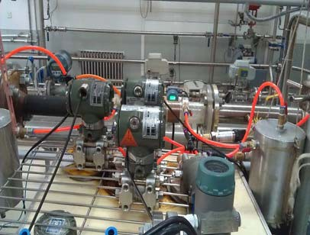 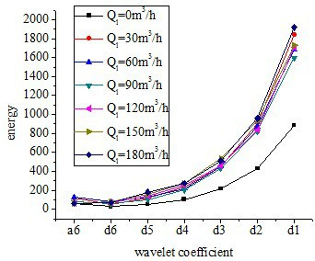

Fig.1. (a) The test system connection diagram; (b) Energy of the scale wavelet coefficients at *Ql* =0 m³/h

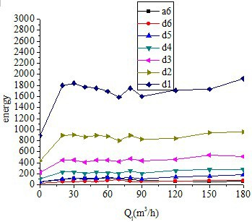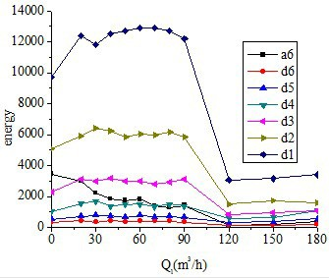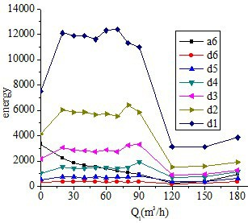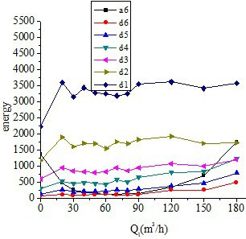

Fig.2. Energy of seven wavelet coefficients at *Ql* =0 m³/h, *Ql* =0.15 m³/h, *Ql* =0.35 m³/h and *Ql* =0.55 m³/h

It is seen in Fig.1(b) that the two-phase flow differential pressure fluctuation signal is a low frequency signal for the energy value between d1 and d2 is higher a little. Fig.2a shows that when the liquid flow rate is 0, the energy value does not change any more though the gas flow rate increases. When the liquid volume flow rate ranges from 0.05~0.45 m³/h, the energy trends are broadly consistent as shown in Fig.2b and Fig.2c (because when the liquid flow rate ranges 0.05, 0.15, 0.25, 0.35, 0.45 (m³/h), the diagram between the wavelet energy and gas flow is similar; as a result, the paper only show the diagrams of the 0.15 and 0.35 working conditions): when the gas flow rate is 0, the current state is the typical stratified flow. It does not exist interphases force, which results in the energy value is much more stable; with the increase of the gas flow, the interphases force begins to come out, which brings the fluctuations in the magnitude and angle interface, so that the stratified flow is destroyed and the energy value increases; when the gas flow ranges from 120 m3/h to 180 m³/h, the gas flow is relatively higher than the liquid flow, which forms entrainment effect on liquid. Consequently the liquid flow is discrete state and the steady state of annular flow observed from testing pipe. In this time the gas entrainment increased with the increase of gas flow, then the gravity of liquid and gas reaches balance, at last the signals tend to steady. As shown in Fig. 2d, when the liquid flow rate is 0.55m3/h, the energy does change much with the increase of the gas flow rate and the overall energy value is low. The reason is that the gas entrainment is relatively lower which can be large enough to entrain the liquid when the gravity becomes heavy as well as the liquid flow in the same gas flow rate; as a result, the flow state is relatively stable without much fluctuations and the energy value is lower.

* 1. *The bi-spectral analysis of the gravity differential pressure signal*

The high-order spectrum *Skx* (1,...,

*k* 1 ) of the random process *x*(*n*) often refers to the *k* 1 dimensional Fourier transform

of the high-order cumulant *ckx* (1,...,

*k* 1 ) . Assumption that the high-order cumulant *ckx* (1,...,

*k* 1 ) is absolute plus, that is,

*Skx* (

1,...,

*k* 1 )  ...

1



*k* 1



*ckx* (1,...,

*k* 1 ) exp(

*j i* )

*i* 1



*k* 1

*i*

*(1)*

It can be proved that if the { *x*(*n*) } is a Gaussian random process, the high-order cumulant ( *k* >2) is identically zero, and the high-order spectrum is also zero. Though there is Gaussian noise in the signal, the high-order spectrum is not affected and the non-Gaussian characteristics can also be extracted from the signal.

In the paper, the third-order spectrum, namely bi-spectrum, is made full use to analyze the experimental data of gravity differential pressure fluctuation signal. The bi-spectrum is defined as follows:

*B* ( ,  )

*c* ( ,  )*e*

*j* ( 1 1 2 2 )

*(2)*

*x* 1 2 3 *x* 1 2



1



2

The high-order spectral estimation method is divided into non-parameter methods and parametric methods. In this paper, it chooses the non-parameter bi-spectrum estimation — indirect algorithm.

For the random process { *x*(*k* ) }, if it is Gaussian distribution, the third-order cumulant c( 1 , 2 ) of all the 1 , 2 is 0, and

the amplitude of the bi-spectrum B( 1 , 2 ) is zero, too. If it is non-Gaussian distribution, the amplitude of the bi-spectrum

B( 1 , 2 ) must be greater than zero. In short, the amplitude of the bi-spectrum B( 1 , 2 ) can be reflected clearly the degree

of signal deviation from the Gaussian distribution.

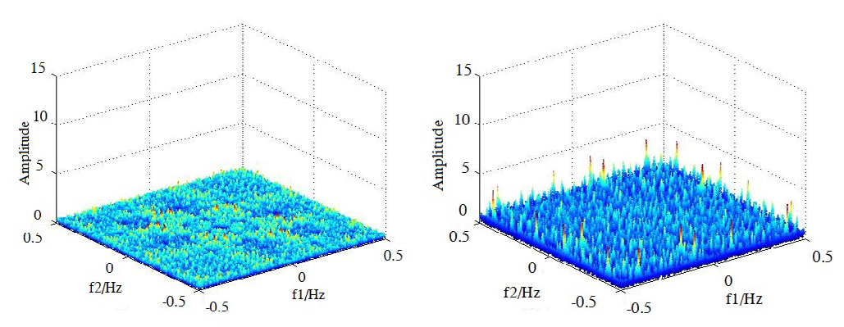

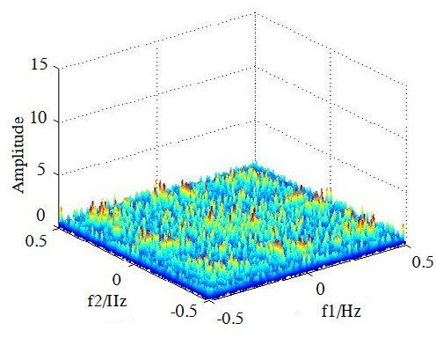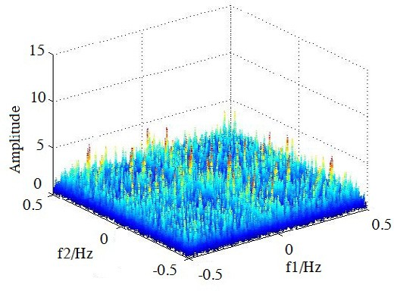

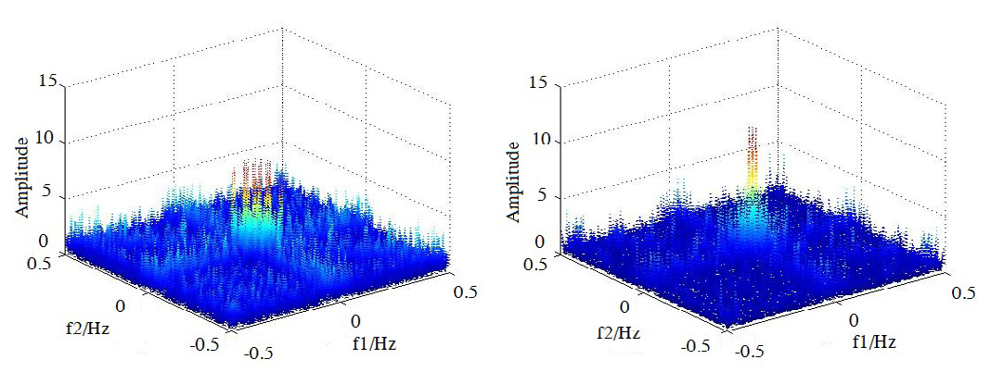

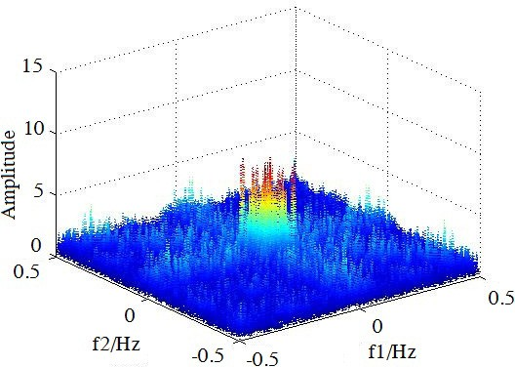

Fig. 3. The bi-spectrum diagram of the gravity differential pressure signal when *Qg* =0m³/h , 30m³/h, 60m³/h, 90m³/h, 120m³/h, 150m³/h, 180m³/h

As shown in Fig.3, it is the bi-spectrum diagram of the gravity differential pressure signal when the liquid volume flow is 0.35m³/h and the gas flow increases from 0m³/h to 180 m³/h when the pressure is 0.1Mpa. Shown in figure Fig 3 the first, when the gas flow rate is 0, the interaction force does not exist between the gas flow and the liquid flow, the gravity differential pressure fluctuations is little and the height of fluctuation signals deviate from the Gaussian distribution is small, and at this time, the bi-spectrum of fluctuations signal ranges evenly and the amplitude is small. Shown in the Fig 3*Qg* from 30 to 90m3/h, with the increase of the gas flow, there will begin to exist interaction force between the gas flow and the liquid flow, and the amplitude of the signal becomes more and more large as well as the amplitude of the bi-spectrum of the fluctuation signal; then, the degree that signal deviates from the Gaussian distribution is most serious. When the gas flow increases to 120m³/h, the entertainment force enhances constantly; consequently, the gas with droplets flow in the center of the pipe, but the liquid comes into being liquid film which flows along the wall forward and flow down partly along the pipe wall. At this time, the liquid film of the bottom of pipe is thicker than the top. As a result, the amplitude of the signal changes slightly but fluctuates violently, and the bi-spectrum peaks concentrate in the area near f1,f2  =(0.1, 0.1). When the gas flow increases to 150m³/h or 180m³/h, the bi-spectrum amplitude changes more apparent to 15; the degree of the fluctuation signals overall deviation from the Gaussian distribution has eased as shown in Fig 3.

## Conclusion

The gravity differential pressure fluctuation signal perpendicular to the horizontal flow is not only related to the phase holdup, but also can reflect the interphases force. By extracting the characteristic quantities, it is proved that the wavelet energy is sensitive to the transition from the laminar flow to the annular flow; besides, by the analysis of the variation the characteristic parameters change with the flow parameters, combining with interphases force to analyze the motivation of flow pattern transition. It is simple, convenient, safe and accurate to obtain the gravity differential pressure fluctuation signal whose characteristics change significantly as the flow pattern changes. This is a new method for the identification of gas-liquid two-phase flow pattern.

# Acknowledgements

This work was supported by the Natural Science Foundation of China (61074174), Natural Science Foundation of Hebei Province (F2011201040), Natural Science Foundation of Hebei University (2009-169), and The key projects of the Department of Education of Hebei Province (ZH2012064).

# References

1. Sun B, Zhou Y L, Wang Q. Differential pressure fluctuation analysis of gas-liquid two-phase intermittent flow using the wigner distribution. Chinese Journal of Scientific Instrument. 2005:26:88-89.
2. Sun B, Zhou Y L, Lu J, Li Y X. Noise recognition of differential pressure fluctuation signal of gas-liquid two-phase flow. Chinese Journal of Scientific Instrument. 2005:26:636-639.
3. Ding H, Huang Z Y, Li H Q. Property of differential pressure fluctuation signal of gas-liquid two-phase flow based on Hilbert-Huang transform. Journal of Chemical Industry and Engineering (China). 2005:56:2294-2302.
4. Zhang H J, Yue W T, Ma L B, Zhou H L. Relationship between fluctuating differential pressure and void fraction of gas-liquid two-phase flow in venturi tube. Journal of Chemical Industry and Engineering (China). 2005:56:2102-2107.
5. Li Q W, Huang Z Y, Ding H, Li H Q. State monitoring of flow pattern of oil-gas two-phase flow based on empirical mode decomposition. Chinese journal of sensors and actuators. 2007:20:224-227.
6. Wang W W, Geng Y F, Huang Z Y. Flow pattern identification of oil-gas two phase flow based on data fusion technique. Chinese journal of sensors and actuators. 2007:20:2128-2132.
7. Jin N D, Miao L Y, Li W B. Symbolic sequence statistical analysis of differential pressure measurement fluctuating signal of gas/liquid two-phase flow. Journal of chemical industry and engineering. 2007:58:327- 334.
8. Ding H, Huang Z Y, Li H Q. Property of differential pressure fluctuation signal of gas-liquid two-phase flow based on Hilbert-Huang transform. Journal of chemical industry and engineering. 2005:56:2294-2302.
9. Ding H, Huang Z Y, Li H Q. Analysis of differential pressure fluctuation signal of gas-liquid two-phase flow based on higher-order spectrum. Journal of Zhejiang University (engineering science). 2006:40:1-4.
10. Fang L D, Zhang T, Xu Y. Analysis of gravity differential pressure fluctuation signal against to the horizontal flow direction in gas-liquid two-phase flow. Chinese Journal of Sensors and Actuators. 2008:21:1184-1189.